TOGAF® Capability Assessment (Phase A)
Version 0.1, 2026-10-30
CSA Mentoring Unit Enterprise Architecture (A3)
Office of Student Mentoring (Mentoring Unit), Center for Student Affairs, University of Asia and the Pacific
Document Version History
Version  Number | Version  Date | Revised By | Description | Filename
0.1 | 2026-10-30 | Emmanuel Velasco (with Laufey) | Phase A draft | Capability Assessment.docx

Contents
1. Purpose of this Document 5
1.1 Output and Input 5
2. Business Capability Assessment 6
2.1 Capabilities of the Business 6
2.2 Baseline Performance Assessment 6
2.3 Future Performance Aspiration 7
2.4 Baseline Capability Assessment 7
2.5 Future Capability Assessment 8
2.6 Impacts to the Business Organization 8
3. IT Capability Assessment 9
3.1 Baseline Maturity Level of Change Process 9
3.2 Target Maturity Level of Change Process 9
3.3 Baseline Maturity Level of Operational Processes 9
3.4 Target Maturity Level of Operational Processes 9
3.5 Baseline Capability 9
3.6 Capacity Assessment 9
3.7 Impacts to the IT Organization 9
4. Architecture Maturity Assessment 10
4.1 Architecture Governance Processes 10
4.2 Organization, Roles, and Responsibilities 10
4.3 Architecture Skills Assessment 10
4.4 Landscape Definition 10
4.5 Standards Definition 10
4.6 Reference Model Definition 10
4.7 Assessment of Re-Use Potential 10
5. Business Transformation Readiness Assessment 11
5.1 Readiness Factors 11
5.2 Vision for Each Readiness Factor 11
5.3 Current Readiness Ratings 11
5.4 Target Readiness Ratings 12
5.5 Readiness Risks 12
Tracking Information
Project Name | CSA Mentoring Unit Enterprise Architecture (A3)
Prepared By | Emmanuel Velasco | Document Version No. | 0.1
Title | Capability Assessment | Document Version Date | 2026-10-30
Reviewed By | Pending: Aldrin, Deejay Clark Datu | Review Date
Distribution List
From | Date | Phone/Email
Emmanuel Velasco | 2026-10-30

To | Action* | Due Date | Phone//Email
OSM Operations Coordinators | Review
CSA Executive Director (Sponsor) | Approve
Architecture team (Velasco, Aldrin, Datu) | Inform
* Action Types: Approve, Review, Inform, File, Action Required, Attend Meeting, Other (please specify)

Purpose of this Document
Before embarking upon a detailed Architecture Definition, it is valuable to understand the baseline and target capability level of the enterprise. This Capability Assessment can be examined on several levels:
- What is the capability level of the enterprise as a whole?
Where does the enterprise wish to increase or optimize capability? What are the architectural focus areas that will support the desired development of the enterprise?
- What is the capability or maturity level of the IT function within the enterprise?
What are the likely implications of conducting the architecture project in terms of design governance, operational governance, skills, and organization structure? What is an appropriate style, level of formality, and amount of detail for the architecture project to fit with the culture and capability of the IT organization?
- What is the capability and maturity of the architecture function within the enterprise?
What architectural assets are currently in existence? Are they maintained and accurate? What standards and reference models need to be considered? Are there likely to be opportunities to create re-usable assets during the architecture project?
- Where capability gaps exist, to what extent is the business ready to transform in order to reach the target capability?
What are the risks to transformation, cultural barriers, and other considerations to be addressed beyond the basic capability gap?

Output and Input
The TOGAF® Content Framework (see Architecture Deliverables) identifies deliverables that are produced as outputs from executing the Architecture Development Method (ADM) cycle and potentially consumed as inputs at other points in the ADM.
This deliverable is produced, updated, and consumed by the ADM Phases:
Deliverable | Output from… | Input to…
Capability Assessment | A, E | B, C, D, E, F

Business Capability Assessment

Capabilities of the Business
The assessment uses the seven capabilities of the Phase B capability map, so that it traces across phases. It goes deepest on pairing, mentor change, session logging, and mentor selection and training. The team's ratings in this document are its own assessment from the interviews, to be validated with OSM.
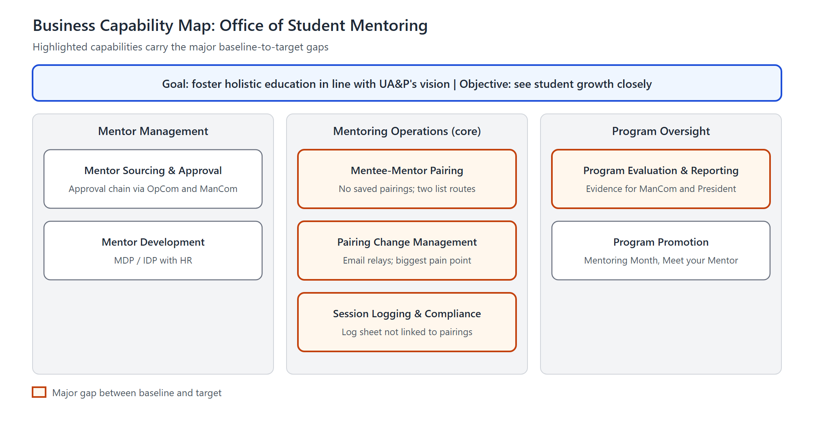
Figure 1. Business Capability Map (from Phase B)

Baseline Performance Assessment
Capability | How it works today
Mentor Sourcing and Approval | OSM receives a list of professors and potential external mentors, and assesses their education and experience against its own criteria. Supervisors recommend, OpCom passes the list on, OSM compiles it, and ManCom approves. The scorecard and criteria are confidential. The approved list goes to the schools.
Mentor Development | About five workshops a year, mandatory as part of the employee development program. Details of the training content are limited.
Mentee-Mentor Pairing | Coordinators compile the pairings based on mentor availability, how many students a mentor can manage, and whether the mentor is from the same school. The list then goes to OSM for its Google Sheet. Coordinators' other duties and the changing Registrar list are the bottlenecks.
Pairing Change Management | The student emails or asks OSM in person. OSM emails the current mentor for approval, then the requested mentor, then the school coordinator, who has the final say.
Session Logging and Compliance Monitoring | The student answers a Google Form. The mentor gets an automatic email and confirms the details. An automatic email then notifies an admin account, and the response is saved in a Google Sheet.
Program Evaluation and Reporting | Participation data is collected, but there is no formal semester report and no way to track whether a session met the student's need.
Program Promotion | Mentoring Month, Mentoring Space, and Meet your Mentor. New students still have to discover the program.

Future Performance Aspiration
Capability | What it must reach
Mentor Sourcing and Approval | Keep the confidential process. The application only receives the approved list.
Mentor Development | Equip mentors with the skills and knowledge to mentor students properly.
Mentee-Mentor Pairing | The same pairing criteria, completed on time and recorded in one register kept across terms.
Pairing Change Management | Fewer mentor-change requests, and a process that does not need a long email chain.
Session Logging and Compliance Monitoring | Responses saved in a secure database, with logging that needs fewer email responses. Every student meets the three-session rule (SM-01).
Program Evaluation and Reporting | One report per semester to the CSA Executive Director and ManCom (SM-08), with a view of whether sessions meet their goals.
Program Promotion | New students know about the program and take part early.

Baseline Capability Assessment
Rated Low, Medium, or High.
Capability | Baseline | Reason
Mentor Sourcing and Approval | Medium | A working approval chain exists; no change is planned
Mentor Development | Medium | Regular mandatory workshops, but the training content is not documented
Mentee-Mentor Pairing | Low | Pairings are late and final lists were not kept
Pairing Change Management | Low | Long email chain with no tracking
Session Logging and Compliance Monitoring | Medium | Logging is automated, but not matched to recorded pairings
Program Evaluation and Reporting | Low | No formal reporting
Program Promotion | Medium | Activities exist; new students still need to discover the program

Future Capability Assessment
Capability | Target | What the target level means
Mentor Sourcing and Approval | Medium | Keep the chain; the application only receives the approved list
Mentor Development | High | Training equips mentors to mentor students properly
Mentee-Mentor Pairing | High | On-time pairings in one register kept across terms
Pairing Change Management | High | Fewer requests, tracked in one queue without an email chain
Session Logging and Compliance Monitoring | High | Secure records matched to pairings, with fewer emails
Program Evaluation and Reporting | High | One report per semester, with a view of session goals
Program Promotion | Medium | New students know about the program early

Impacts to the Business Organization
Assessment of likely impacts to the Business organization resulting from successful deployment of the target:
- OSM staff spend less time on email relays and on chasing lists, and more on monitoring and mentor development.
- OSM names one data owner who keeps the pairing register current each term. This is a new responsibility for a two-person unit.
- School Mentoring Coordinators work in the register instead of their own lists. They keep the pairing decision.
- Mentors declare their capacity each term and confirm sessions as they do now.

IT Capability Assessment
OSM has no IT function of its own, so this section is kept short.

Baseline Maturity Level of Change Process
Low. Changes are requested from the IT Office informally, one form or script at a time.

Target Maturity Level of Change Process
Medium. Changes to the mentoring tools go through one named owner at OSM and an agreed request to the IT Office.

Baseline Maturity Level of Operational Processes
Low to Medium. Session logging is automated with Google Forms and a script. Everything else runs on email and separate spreadsheets.

Target Maturity Level of Operational Processes
Medium. All five application services (S1 to S5) run as one workflow, with the register as the shared source of truth.

Baseline Capability
Email and Google Workspace (Forms, Sheets, Gmail, Apps Script, Drive). The IT Office builds the forms and sheet connections, and OSM owns the tools and records.

Capacity Assessment
Limited. OSM has two staff, and its capacity for new maintenance work is low. The capacity of the IT Office to take on more work has not been assessed and should be confirmed.

Impacts to the IT Organization
Assessment of likely impacts to the IT organization resulting from execution of the architecture project: the IT Office would support the new application within the Google Workspace it already supports, and maintain its scripts.

Architecture Maturity Assessment
The unit has no architecture function. This work is its first architecture effort, so the maturity is low across all of these areas.

Architecture Governance Processes
None specific to architecture. Programs and policies are governed through CSA and ManCom.

Organization, Roles, and Responsibilities
The student architecture team carries the work, with OSM as the business owner and the CSA Executive Director as sponsor.

Architecture Skills Assessment
OSM staff skills in architecture have not been assessed. The team is applying TOGAF as part of its coursework.

Landscape Definition
The Phases B to D documents are the first description of the unit's architecture landscape.

Standards Definition
The UA&P Student Handbook on Mentoring, the three-session policy, the Phase D technology standards, and the Data Privacy Act of 2012.

Reference Model Definition
None in use.

Assessment of Re-Use Potential
Good. The team can reuse Google Workspace, the existing session-log form and script, and the Architecture Principles from the Enterprise Proposal.

Business Transformation Readiness Assessment
The ratings below are the team's proposal from the interviews, to be validated with OSM.

Readiness Factors
- Need for change
- Sponsorship
- Shared vision
- OSM staff
- Coordinators
- Mentors
- Students
- Accountability
- IT capacity

Vision for Each Readiness Factor
Readiness factor | Vision
Need for change | Everyone sees why the change is needed
Sponsorship | Visible support from the top
Shared vision | One agreed target across OSM and the schools
OSM staff | Staff ready to own the workflow
Coordinators | Coordinators work in one register
Mentors | Mentors respond and declare capacity
Students | Students take part and log sessions
Accountability | A named owner for the data
IT capacity | Enough support for the new tools

Current Readiness Ratings
Readiness factor | Current | Reason
Need for change | High | The non-negotiable rule and its effect on enrollment
Sponsorship | High | The President's mandate, with the CSA Executive Director as sponsor
Shared vision | Medium | The purpose is clear, but the target is not yet agreed with OSM
OSM staff | Medium | They want faster pairings, but have only two people
Coordinators | Medium | They want a smooth process, but have other duties
Mentors | Medium | They are committed, but some do not reply and schedules conflict
Students | Low | They participate when prompted; new students are more active than older ones
Accountability | Low | No one owns the pairing records today
IT capacity | Medium | Google Workspace and IT Office support exist; capacity is unconfirmed

Target Readiness Ratings
Readiness factor | Target
Need for change | High
Sponsorship | High
Shared vision | High
OSM staff | High
Coordinators | High
Mentors | High
Students | High
Accountability | High
IT capacity | Medium

Readiness Risks
- OSM has only two staff, so upkeep of the register could overload them.
- Coordinators may keep their own lists if the register adds work, especially as coordinators change from year to year.
- A 100% compliance target may be difficult to reach in practice.
- Students may fail to log sessions, which would understate compliance.
- The mentor shortage could limit pairing even with a better process.
Sources: Interview with OSM (2026-09-11); Interview with OSM (2026-09-28); Interview with SSE Mentoring Coordinator (2026-10-16); Interview with SED Mentoring Coordinator (2026-10-20); Phase A inputs from E. Velasco (2026-10-30); Phase B Architecture Requirements Specification and Architecture Roadmap; Phases C and D Architecture Deliverables.

